**How to Use validation control in Asp.net**

**Step 1:open visual studio2019**

**Step2:file->new->website->asp.net web application->asp.net web application(.net framework)->next->empty website->add->ok.**

**Step 3:in solution explorer->right click on new validation form->add->new item->webform**

**Step 4:now click on design->**

**Step5: first we have add a table**

**Goto toolbox->click on HTML tab->table->click on it**

**Step 6:->adjust ur table->add row->select row->right click->insert row below->n design ur form accrding to image given below**

**Step7:Name:**

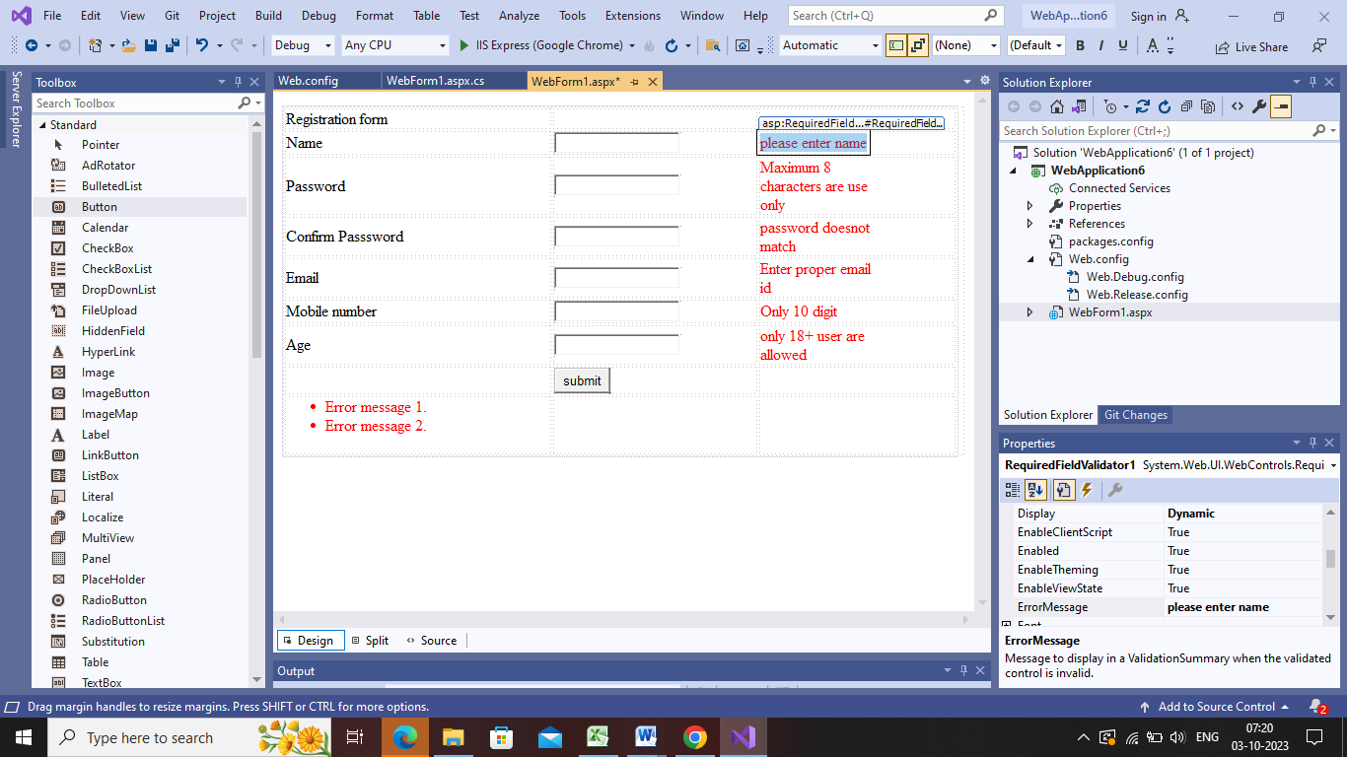

**Password:**

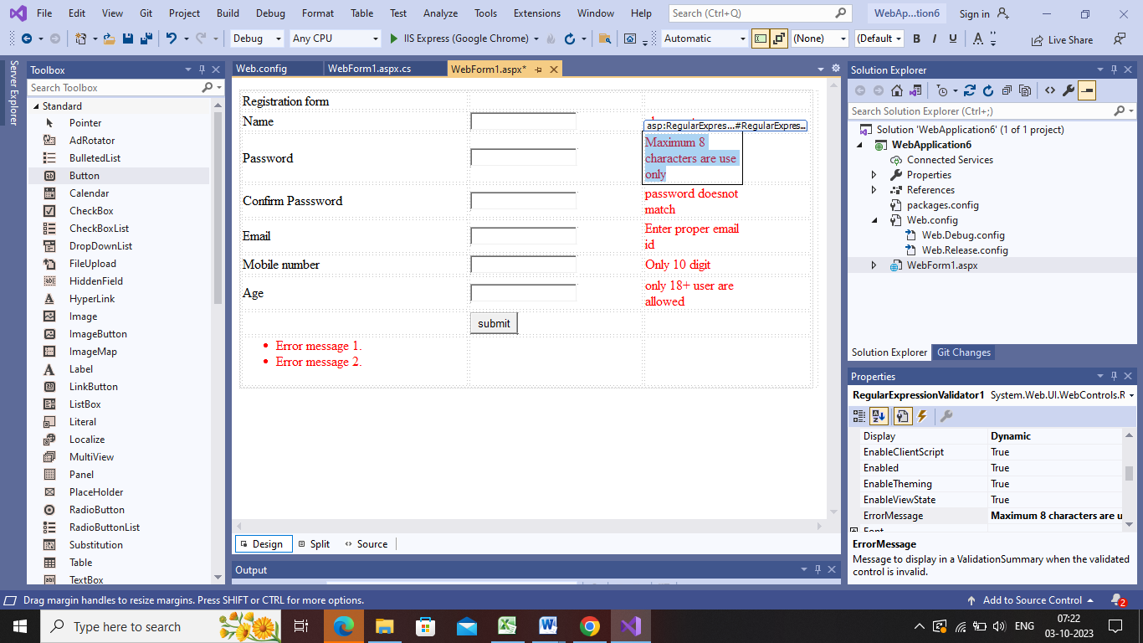

**Confirm password(Compare validator☺)**

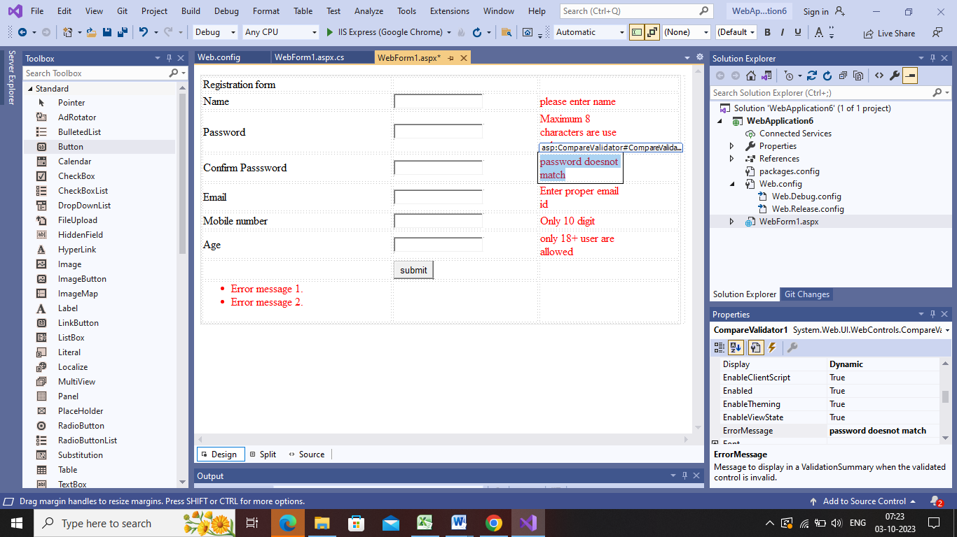

**Email(regular expression validator)**

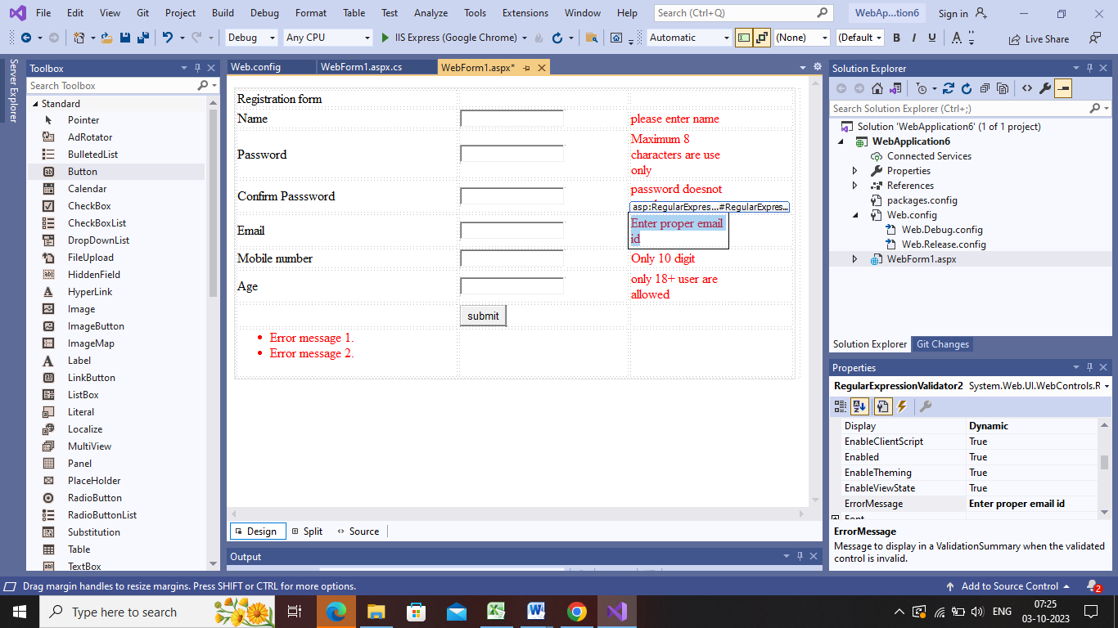

**Mobile number(regular expression validator)**

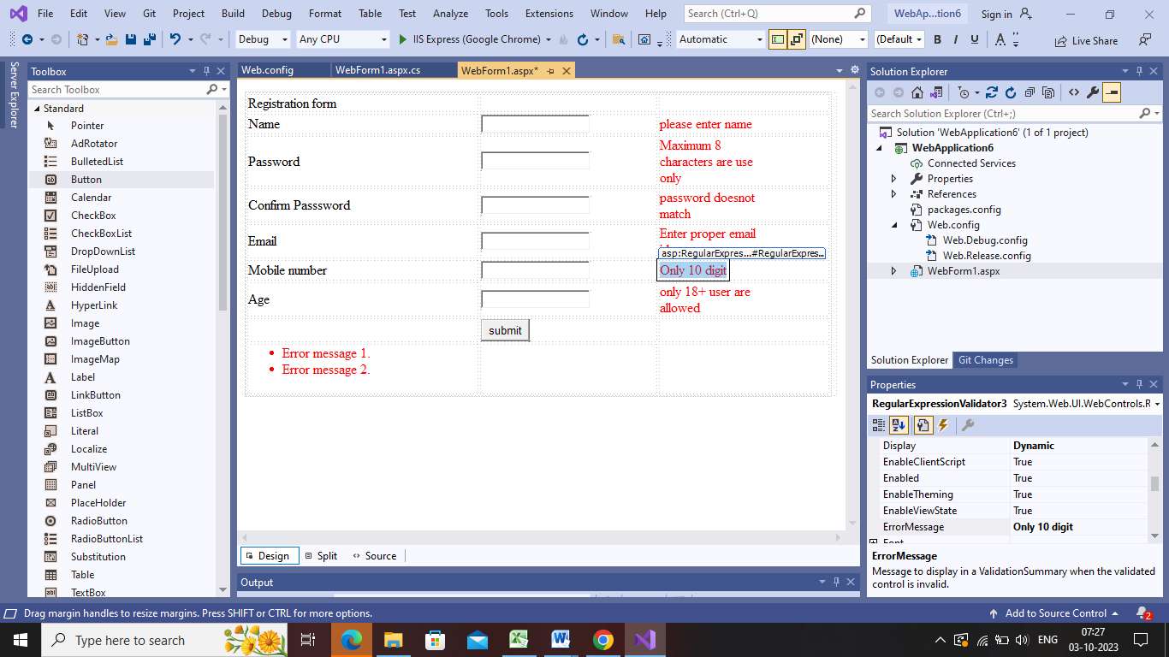

**Age(Range validator):**

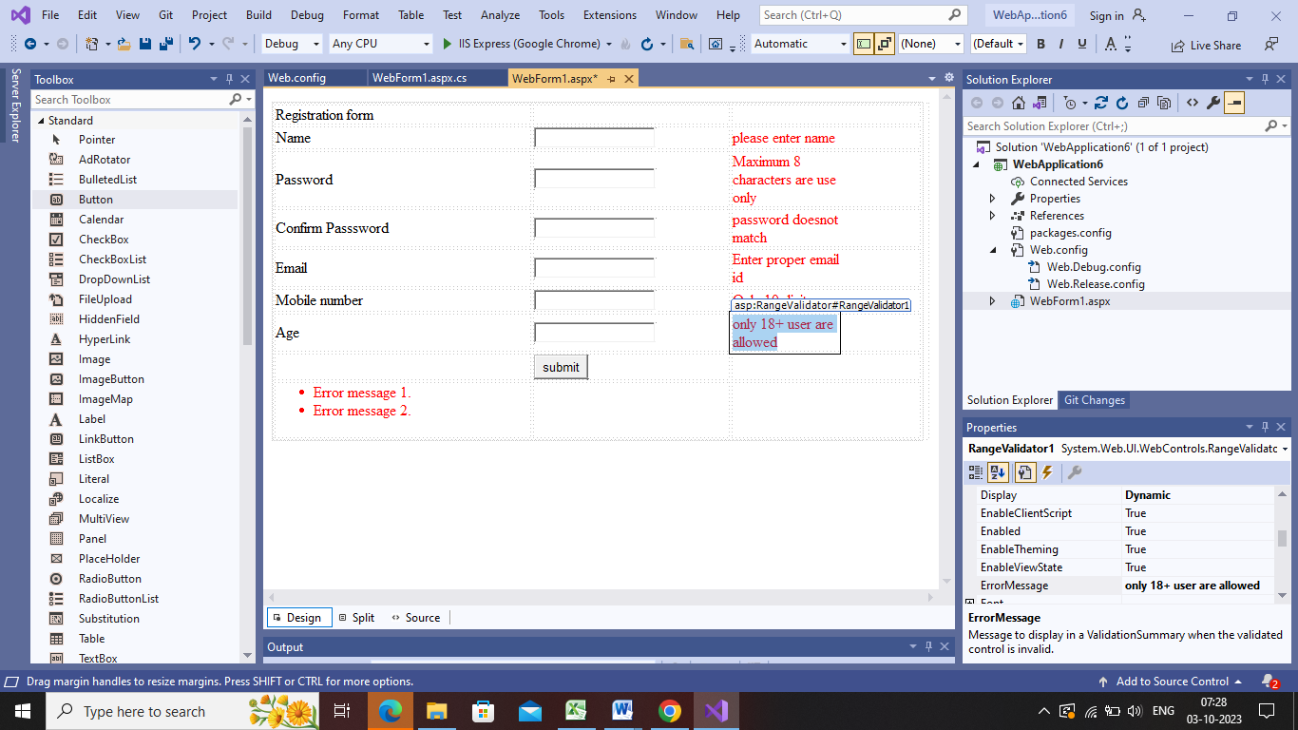

**Validation summary:**

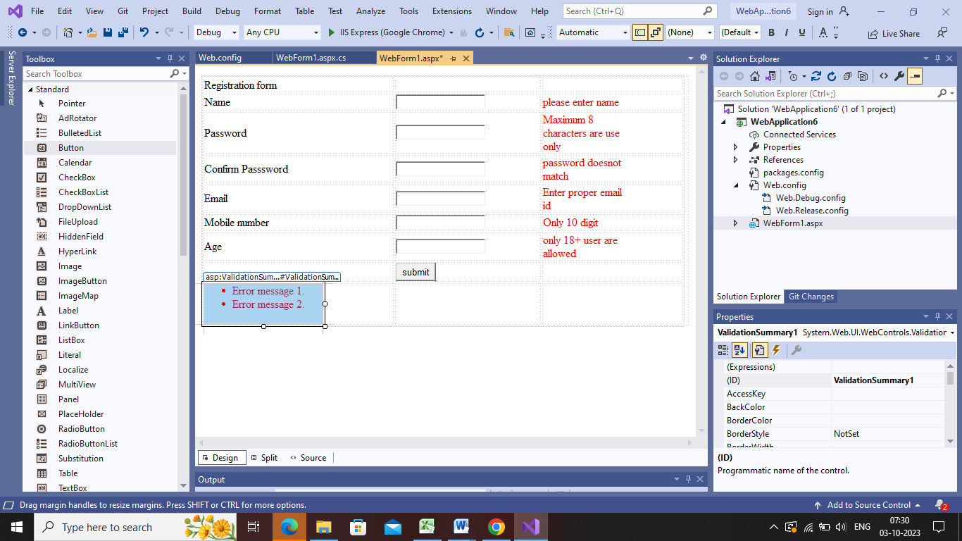

**Validation control:**

**1.Name(Required field validator):**

|  |  |  |
| --- | --- | --- |
| **Required field validator** | **Property** | **Options** |
|  | **Display** | **Dynamic** |
|  | **Forecolor** | **Red** |
|  | **Errormessage** | **Please enter name** |
|  | **Control to validate** | **Textbox1** |
|  | **Setfocus on error** | **true** |
|  |  |  |

**2.password(Required Expression validator)**

|  |  |  |
| --- | --- | --- |
| **Required expression validator** | **Property** | **Options** |
|  | **Display** | **Dynamic** |
|  | **Forecolor** | **Red** |
|  | **Errormessage** | **Maximum 8 characters are use only** |
|  | **Validation expression** | **^[a-zA-Z0-9'@#.\s]{8}$** |
|  | **Setfocus on error** | **true** |
|  | **Control to validate** | **Textbox2** |

**Confirm password(Compare validator):**

|  |  |  |
| --- | --- | --- |
| **Compare validator** | **Property** | **Options** |
|  | **Display** | **Dynamic** |
|  | **Forecolor** | **Red** |
|  | **Control to compare** | **Textbox2** |
|  | **Control to validate** | **Textbox3** |
|  | **Setfocus on error** | **true** |
|  | **Error message** | **Password doesnot match** |

**Email(regular expression validator):**

|  |  |  |
| --- | --- | --- |
| **Regular expression validator** | **Property** | **Options** |
|  | **Display** | **Dynamic** |
|  | **Forecolor** | **Red** |
|  | **Errormessage** | **Enter proper email id** |
|  | **Validation expression** | **Click here…**  **Select internet email address** |
|  | **Setfocus on error** | **true** |
|  | **Control to validate** | **Textbox4** |

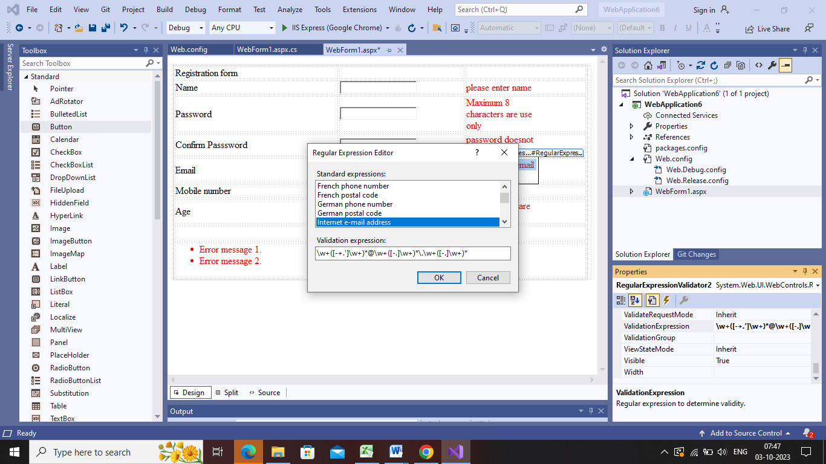

**Mobile number(Regular expression validator):**

|  |  |  |
| --- | --- | --- |
| **Regular expression validator** | **Property** | **Options** |
|  | **Display** | **Dynamic** |
|  | **Forecolor** | **Red** |
|  | **Errormessage** | **Only 10 digit** |
|  | **Validation expression** | **^[0-9]{10}$** |
|  | **Setfocus on error** | **true** |
|  | **Control to validate** | **Textbox5** |

**Age(Range validator):**

|  |  |  |
| --- | --- | --- |
| **Regular expression validator** | **Property** | **Options** |
|  | **Display** | **Dynamic** |
|  | **Forecolor** | **Red** |
|  | **Errormessage** | **Only 18+ user are allowed** |
|  | **Maximum value** | **60** |
|  | **minimumvalue** | **18** |
|  | **Setfocus on error** | **true** |
|  | **Control to validate** | **Textbox6** |
|  | **type** | **integer** |
|  |  |  |

**Validation summary:**

|  |  |  |
| --- | --- | --- |
| **Validation summary** | **property** | **option** |
|  | **Forecolor** | **Red** |
|  | **Show messagebox** | **true** |
|  |  |  |

**Now save the program and run it**

appSettings>

<add key="ValidationSetting:UnobtrusiveValidationMode" value="None"></add>

</appSettings>